|  |
| --- |
| OrangeHRM – Recruitment Module Live Project |
| **Project Functional Requirement Specification Version 1.0** |
|  |
| **Prepared by: Sharon Paul V**  **Reviewed by: Ragavendhra BN** |
|  |

|  |
| --- |
|  |

Contents

1. Purpose of the document: 2

2. Project Overview: 2

2.1 Audience: 2

2.2 Hardware and Software components: 3

3. Information Architecture 3

3.1 Recruitment Module 4

3.1.1 Recruitment Module 4

3.1.2 Candidate 5

3.1.3 Vacancy 7

4. Sign-Off Document 9

# Purpose of the document:

This is **not** a project plan. It is a guide for system architecture and development,not for phasing, timelines or deliverables.

This document is divided into three sections:

• Project Overview

• Information Architecture

• Site Design

# Project Overview:

## 2.1 Audience:

This document is intended as a complete guide for ESS-User in using OrangeHRM 3.0. This

document is specially designed for non-specialists; specialists may find the document a useful point of reference. By reading this guide, you will learn how to use OrangeHRM through the elements of the graphical user interface and what's behind some of the advanced features that are not always obvious at first sight. It will hopefully guide you around some common problems that frequently appear for users of OrangeHRM.

## 2.2 Hardware and Software components:

OrangeHRM’s servers will be hosted at X company’s site.

OrangeHRM will be hosted on two servers: One to host the actual website and (language)code, and the other to host the (database name)database.

# Information Architecture

Log in to the OrangeHRM System using your ESS-User account that has been created by the HR Admin as shown in Figure 1.0.



## 3.1 Recruitment Module

Recruitment Module is a powerful tool providing HR of the company with the ability to view relevant information such as details of the candidates and the vacancies in the organisation with an internet enabled PC.

The functionality of this module spans through the entire system, making information available anywhere, anytime. All information is subject to company’s defined security policy, where admin can only view the information he/she is authorized to. Admin can only edit the fields in the Recruitment Module, maintaining the security and confidentiality of employee information.

### 3.1.1 Recruitment Module

When an admin logs into the system and uses the Recruitment module it shows candidates list and vacancy as shown in Figure 3.1. They are able to edit and enter certain fields.

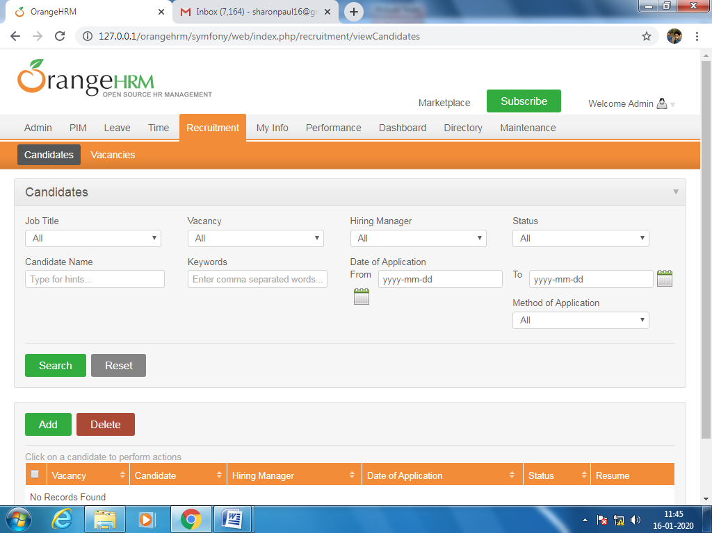

Figure 3.1

### 3.1.2 Candidate

The following are restricted fields where an Admin can only make changes to the following details.

* Job Title
* Vacancy
* Hiring manager
* Status
* Date of application
* Method of application

The Admin can choose the option from the drop down list shown in Figure 3.2. 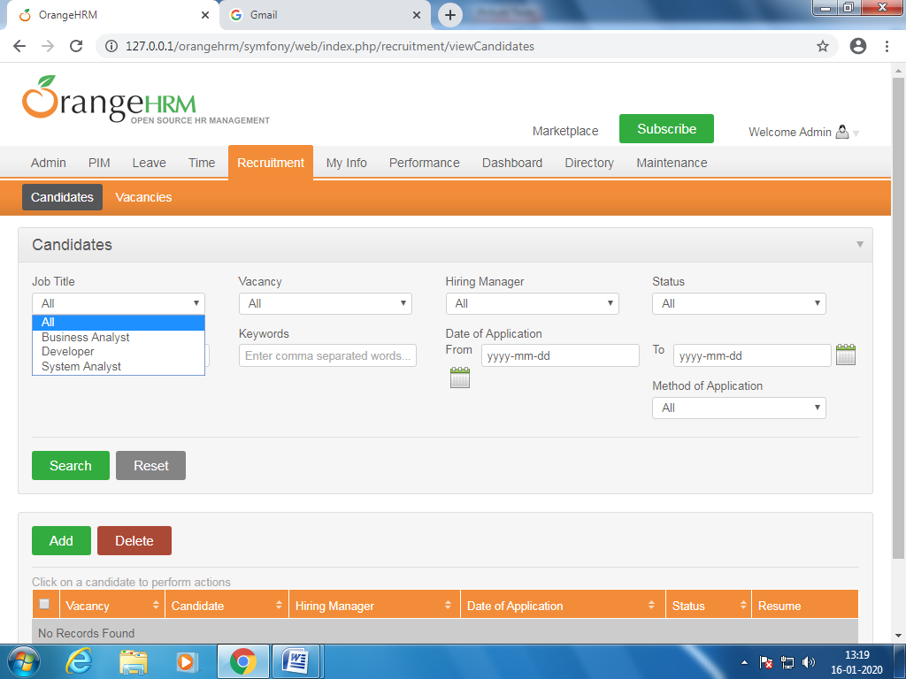

Figure 3.2

There are many options that can be used in filtering the details of the candidate.

From the status option we can choose any of this Figure 3.3.

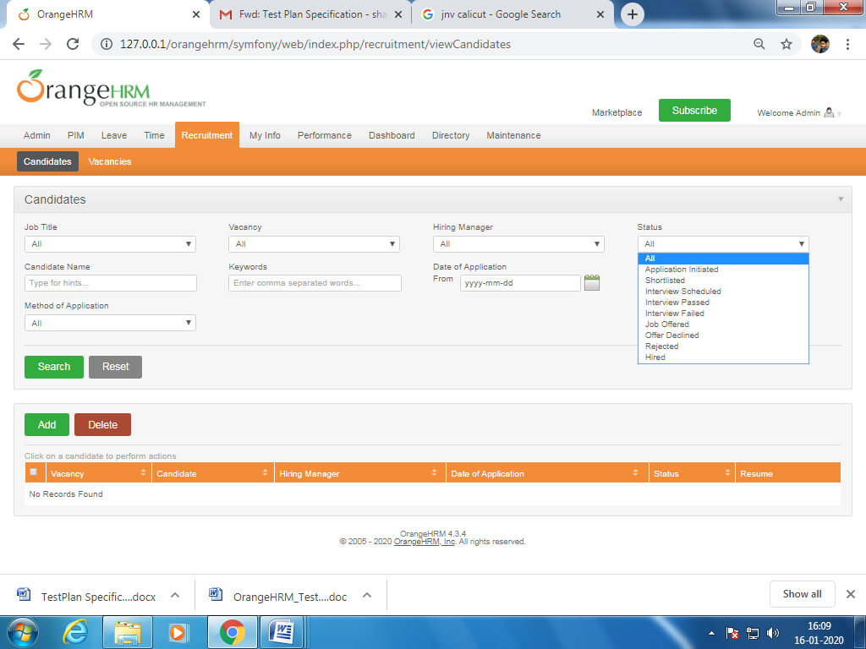

Figure 3.3

Click “Add” to add the details of the candidate Figure 3.4.

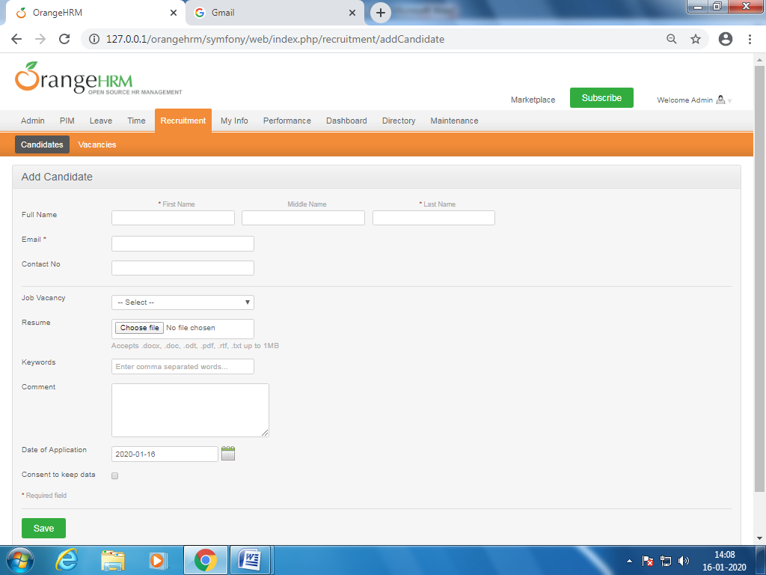

Figure 3.4

You can add the following details:

* First Name
* Middle Name
* Last Name
* Email
* Job Vacancy-select from the drop down.
* Resume

Once you complete this form click on “save”.

We can search the details of the added candidates by using the “search” button.

And can delete the details by selecting the candidate the click “delete”.

### 3.1.3 Vacancy

Vacancy details can be obtained using this option. Click on “vacancy” in Figure 3.5 will appear.

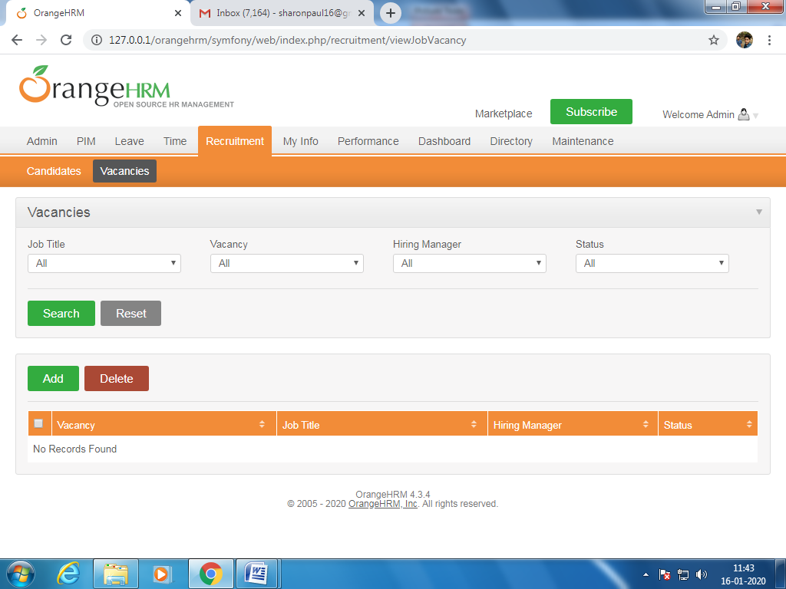

Figure 3.5

Click “Add” to enter the job vacancy.

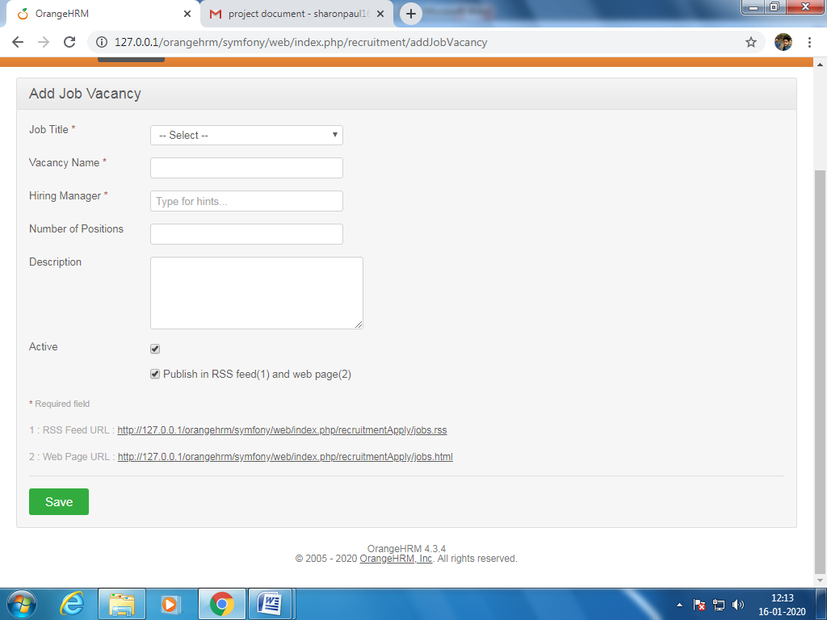

You can edit the following:

* Job Title– Select from the drop down
* vacancy name
* Hiring manager
* Number of positions

Once you have completed this form click “Save”.

# Sign-Off Document

_____________________________________________________________________________

The following parties have read and agree with this Requirements Definition document for the OrangeHRM application account module functionality.

After approval of this Requirements Definition phase, any significant changes in the scope of this project will require validation of existing project costs and schedules.

_______________________________________________________________________

Name Date

Business Lead

______________________________________________________________________

Name Date

Project Manager

**Prepared by: Sharon Paul V**